Exploratory Data Analysis (EDA) Report

Data modelling
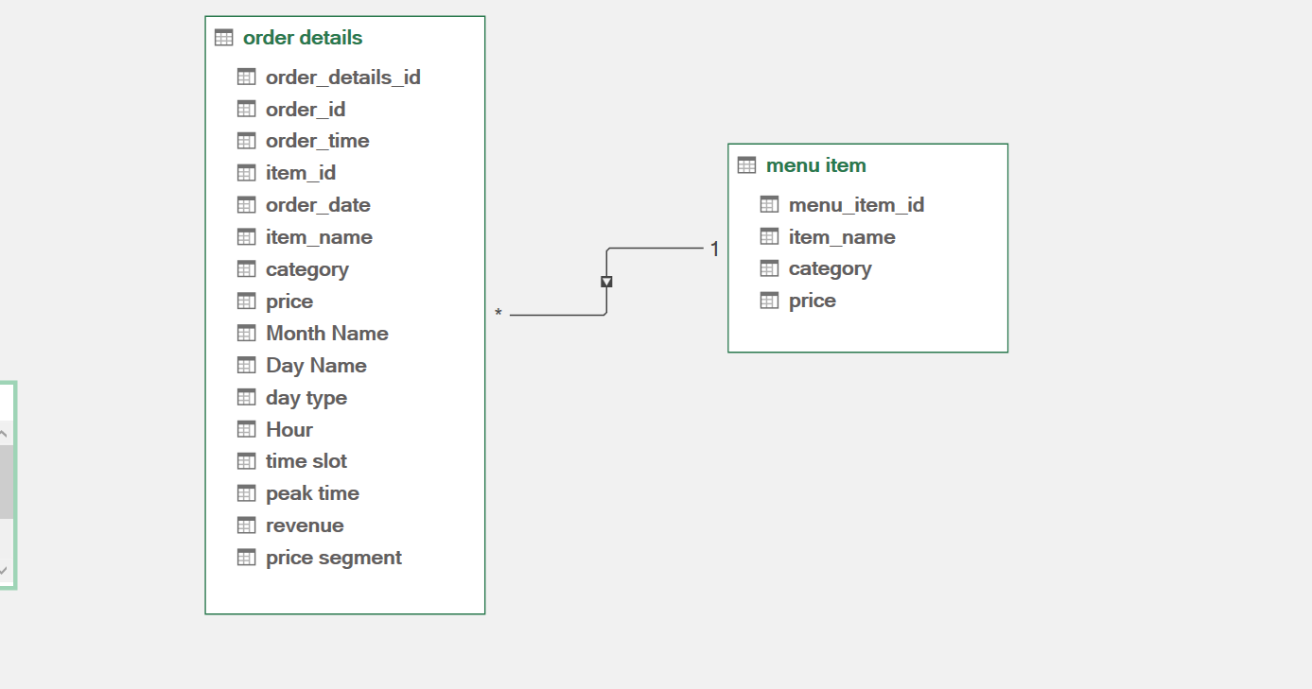

Note: this is the outcome after data pre processing

- Introduction

This project analyzes a B2C food ordering dataset consisting of transactional order data and menu item details. Customers place orders directly by selecting items from the menu. The objective of this analysis is to understand sales performance, customer ordering patterns, and product-level insights to support business decision-making.

2. Dataset Description
Order Details Table
- Total Rows: 12,234
- Columns:
  - Order ID
  - Order Date
  - Order Time
  - Item ID
This table represents item-level transactions where each row corresponds to a single item within an order.
Menu Items Table
- Total Rows: 32
- Columns:
  - Menu Item ID
  - Item Name
  - Category
  - Price
This table contains static information about products offered.

3. Data Preparation

- Merged tables using Item ID
- Removed duplicates
- Fixed data types
- Handled date format inconsistencies using locale-based conversion
- Created derived columns (month, day, time slot, etc.)

Data preprocessing and cleaning were performed using Power Query to ensure data consistency and reliability. This included handling data type conversions, resolving date format inconsistencies using appropriate locale settings, and preparing the dataset for time-based analysis. Detailed data transformation steps are documented separately in the Data Processing Report.

4. Feature Engineering

Additional columns were created to enhance analysis:
Time-Based Features
- Month
- Day Name
- Weekday vs Weekend
- Hour
- Time Slot (Morning / Afternoon / Evening)
- Peak vs Non-Peak Indicator
Business Metrics
- Revenue (based on item price)
- Price Segment (Low / Medium / High)
- Premium vs Budget classification

5. Key Analysis Performed

The following business questions were explored:
- Total sales revenue
- Number of orders per day (distinct order count)
- Most frequently ordered items
- Revenue trends across months
- Average number of items per order
- Order distribution by time of day
- Weekday vs weekend performance comparison
- Top 5 best-performing menu items

6. Key Insights
- Certain categories contribute significantly higher revenue compared to others
- Peak ordering hours are concentrated during lunch and evening periods
- Weekends generally show higher order volumes than weekdays
- A small number of items contribute to a large portion of total sales
- Customer orders typically consist of a limited number of items

7. Limitations
- No customer-level data is available (e.g., customer ID, demographics)
- No information on discounts, profit margins, or acquisition channels
- Customer behavior metrics such as loyalty and churn cannot be derived

8. Conclusion
The analysis provides valuable insights into sales trends, product performance, and ordering behavior. These insights can help in optimizing menu offerings, improving operational efficiency, and identifying peak business hours. Future enhancements with additional data sources can further strengthen the analysis.

